ALYSEUM - MULTI - User's manual 1.1

Introduction
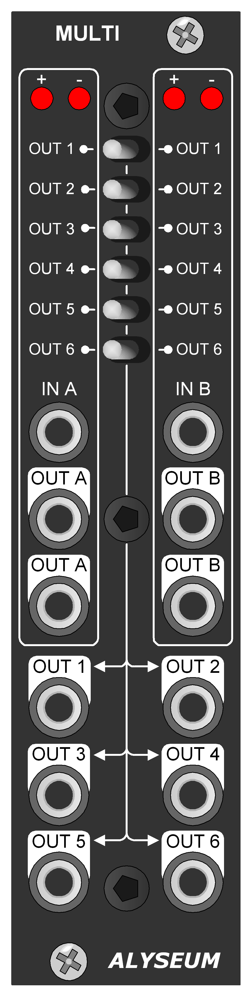

Yes, http://www.modulargrid.net/is full of multiple modules, one more you think, yes but different from all of them.

MULTI is exactly as I dreamed it: Dual, cunning and instantly configurable, making it unique and versatile.

Of course, it is of the active type and uses OPA4171 operational amplifiers with very low drift.

What makes the differences with the competitors :
- Dual Multi A & MULTI B, each with two direct buffered outputs.
- Individually, each of the 6 buffered outputs can be connected to either input A or B via a toggle switch, allowing you to configure your MULTI instantly and freely.
- Both red LED on each input gives a luminous visibility to your signals in terms of polarity and level!

Why polarity indicator with 2 LED?
Majority of manufacturer use a single bicolor LED, it's the most economical solution.
Except that a part of the world's population is color-blind (8% in men and 0.45% in women) and that rapid polarity switching is much more relevant with 2 LEDs.

Hardware

Package Content
- One MULTI module with Eurorack compliant front panel.
- One plastic bag containing:
  - Two M3 screws + nylon washers.
  - One 10/16 pins power ribbon cable.
    - Warranty & user manual access card.

Specifications
  - Outputs with low-drift trackers type OPA-4171
  - Gain error between In and Out: maximum 0,05%
  - Power requirements (2 LED On): +12V= 15mA / -12V= 15mA maximum.
      - Power supply is fully protected against reverse ribbon cable insertion.
  - Eurorack 6 HP wide, maximum depth 26mm.

Installation
Choose the installation location of your unit carefully:
- Avoid placing it in direct sunlight or close to a source of heat.
- Avoid locations subject to vibrations, excessive dust, heat, cold, moisture or rain.

Procedure:
- Make sure to discharge any built-up static electricity from yourself and your devices before touching or connecting one device to another.
- Only connect the module to a Eurorack bus board powered by a specified A-100 power supply.
- Switch OFF, disconnect the Eurorack case from the main power supply by unplugging it from the wall socket!
- Make absolutely certain that the ribbon cable has the right orientation by connecting the indicated red stripe on the negative 12 Volt side of your Eurorack case bus board.
- Carefully place the module on an appropriately spaced spot on your Eurorack and fasten it firmly in place with the supplied screws and nylon washers.
- Reconnect the Eurorack case power cable back into the main power supply and switch the case power on.
- If it doesn’t seem to be working as expected (Initialization LEDs sequence), immediately disconnect the system from the main power supply again. In this case, double-check the connections, making completely sure that the ribbon cable is the right way round where it connects to the module and the bus.

How to use
A drawing is worth a thousand words ☺

Miscellaneous

Disclaimer
All rights reserved. Reproduction in whole or part of this document is prohibited without the express permission of ALYSEUM.
© 2011-2099 ALYSEUM.
The information and specifications described in this manual are subject to change without prior notice.
Throughout this manual, trademarked names might be used. We state herein that we are using the name to the benefit of the trademark owner, with no intention of infringement.

Warranty and repair
ALYSEUM warrants to you, the original purchaser, that each of its products will be free from defects in materials and workmanship for a period of two years following the date of purchase.
This warranty does not apply to any products which have been repaired or altered by other than ALYSEUM, or which have been subject to ESD, moisture, abuse, accident, improper installation or use.
ALYSEUM assumes no liability as a consequence of such events under the terms of this Warranty.
Please, consult your dealer for more details or visit our support page on http://www.alyseum.com/support before any action.

